Name: Orçun Sami Tandoğan Exercise 6 19.1.2021
ID: 2535037
Outline:
Answers
A Roc Curve
B Optimal Thresholds & Costs
Coding Part
Modules are imported
A Part-)
Created 2 Samples, Acme is Assumed as 1 for classifier
Data Trained, Transformed and ROC Curve is completed
B Part-)
Threshold list is created from Logistic Regression Module which has been used.
Cost function is designed
Cos function is applied for 3 cases, I, II and III
Answers:
A:
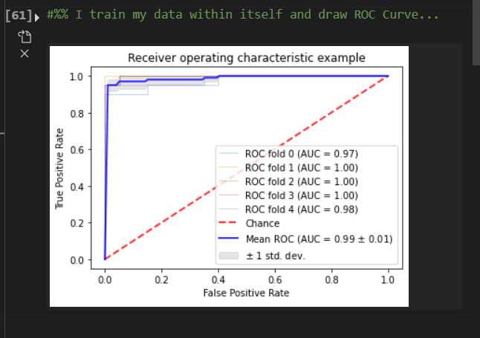
B:
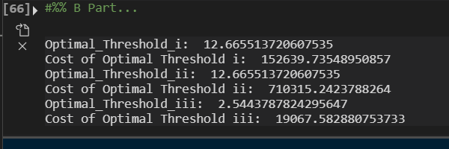
Coding Part
#%%
import numpy as np
import matplotlib.pyplot as plt
import pandas as pd
from sklearn.model_selection import train_test_split
from sklearn.preprocessing import StandardScaler
from sklearn.linear_model import LogisticRegression
from sklearn.metrics import roc_curve, auc
from sklearn import svm, datasets
from sklearn.model_selection import StratifiedKFold
from sklearn.metrics import plot_roc_curve
from scipy.stats import norm
import scipy.stats as stats

#%% Draw the ROC curve for the classifier. You may take either class (Acme or BioTek) as the positive class.
# I created two samples
acmetemp_x=np.random.normal(8,2,100)
biotektemp_x=np.random.normal(18,4,100)
X=np.concatenate([acmetemp_x,biotektemp_x])
X=X.reshape(-1,1)
# I assumed Acme`s class is 0 and Biotek`s 1
acmetemp_y=[0] * 100
biotektemp_y=[1] * 100
y = np.append(acmetemp_y,biotektemp_y)
#%% I train my data within itself and draw ROC Curve
random_state = np.random.RandomState(0)
# Trainning
X_train, X_test, y_train, y_test = train_test_split(X, y, test_size = 0.20, random_state = 4)
# Transforming Data
sc_X = StandardScaler()
X_train = sc_X.fit_transform(X_train)
X_test = sc_X.transform(X_test)
# Logistic Regression Model Usage
model_logistic = LogisticRegression()
model_logistic.fit(X_train, y_train)
y_pred_logistic = model_logistic.decision_function(X_test)

logistic_fpr, logistic_tpr, lr_threshold = roc_curve(y_test, y_pred_logistic)

cv = StratifiedKFold(n_splits=5) # Several split numbers used, 5 is satisfying enough
classifier = model_logistic

tprs = []
aucs = []
mean_fpr = np.linspace(0, 1, 100)
fig, ax = plt.subplots()
for i, (train, test) in enumerate(cv.split(X, y)):
classifier.fit(X[train], y[train])
viz = plot_roc_curve(classifier, X[test], y[test],
name='ROC fold {}'.format(i),
alpha=0.3, lw=1, ax=ax)
interp_tpr = np.interp(mean_fpr, viz.fpr, viz.tpr)
interp_tpr[0] = 0.0
tprs.append(interp_tpr)
aucs.append(viz.roc_auc)

ax.plot([0, 1], [0, 1], linestyle='--', lw=2, color='r',
label='Chance', alpha=.8)

mean_tpr = np.mean(tprs, axis=0)
mean_tpr[-1] = 1.0
mean_auc = auc(mean_fpr, mean_tpr)
std_auc = np.std(aucs)
ax.plot(mean_fpr, mean_tpr, color='b',
label=r'Mean ROC (AUC = %0.2f $\pm$ %0.2f)' % (mean_auc, std_auc),
lw=2, alpha=.8)

std_tpr = np.std(tprs, axis=0)
tprs_upper = np.minimum(mean_tpr + std_tpr, 1)
tprs_lower = np.maximum(mean_tpr - std_tpr, 0)
ax.fill_between(mean_fpr, tprs_lower, tprs_upper, color='grey', alpha=.2,
label=r'$\pm$ 1 std. dev.')

ax.set(xlim=[-0.05, 1.05], ylim=[-0.05, 1.05],
title="Receiver operating characteristic example")
ax.legend(loc="lower right")
plt.show()

#%% B Part
# First I created threshold list
rocdata= roc_curve(y,X) # [0]: False Positives [1]: True Positive Rate [2]: Thresholds
threshold_list= rocdata[2]
# I designed fucntion which gives us according to data we have like:
# aN: # of acme cases, bN: # of biotek cases, aC: Cost of Acme case, bC: Cost of Biotek Case
def cost(aN,bN,aC,bC):
temp = [0,0]
for i in threshold_list:
tp = stats.norm.cdf(i,8,2) * aN
fn = (1 - stats.norm.cdf(i,8,2)) * aN
fp = stats.norm.cdf(i,4,18) * bN
tn = (1 - stats.norm.cdf(i,4,18)) * bN
sumT = (tp * aC) - (fn * aC) + (tn * bC) - (fp * bC)
if temp[0] < sumT:
temp[0] = sumT
temp[1] = i
return temp
# i-) Drug α and β both cost 50 TL and there are 5,000 Acme and 5,000 BioTek containers in the mixed-up warehouse.
Optimized_Cost_and_Threshold_i= cost(5000, 5000, 50, 50)
Optimal_Threshold_i = Optimized_Cost_and_Threshold_i[1]
# ii) Drug α and β both cost 100 TL and there are 8,000 Acme and 2,000 BioTek containers in the mixed-up warehouse.
Optimized_Cost_and_Threshold_ii= cost(8000, 2000, 100, 100)
Optimal_Threshold_ii = Optimized_Cost_and_Threshold_ii[1]
# iii) Drug α costs 100TL, drug β costs 50TL. There are 1,000 Acme and 9,000 BioTek containers in the mixed-up warehouse.
Optimized_Cost_and_Threshold_iii= cost(1000, 9000, 10, 50)
Optimal_Threshold_iii = Optimized_Cost_and_Threshold_iii[1]
print('Optimal_Threshold_i: ',Optimal_Threshold_i,'\nOptimal_Threshold_ii: ', Optimal_Threshold_ii,'\nOptimal_Threshold_iii: ',Optimal_Threshold_iii)

